**Project Log**

**Date: 30-10-2024**

**Mail of problem statement received from the mentor.**

**Problem Statement 2:** Scenario: Modern life often complicates efforts to maintain a healthy lifestyle, with busy schedules making it difficult to track and balance physical activity, diet, and mental health. For example, a busy professional may find it challenging to keep track of their daily exercise, maintain a balanced diet, and manage stress. Without a comprehensive tool to monitor these aspects, individuals may struggle to identify patterns and make informed decisions about their health. Existing health apps often focus on isolated aspects like diet tracking or workout logging, leaving users without a holistic view of their overall well-being.

**Team Members:**

|  |  |  |  |
| --- | --- | --- | --- |
| **Group** | **Learner 1** | **Learner 2** | **Capstone Project Number** |
| 2 | Ananthakrishnan T H | Ajay A | 2 |

**Date: 01-11-2024**

**Agenda:**

1. Discuss about project and find out few strong points to design project. (One or two pages).

**Health and Wellness Application**

**1. Technology Stack Setup**

**Backend:**

* Set up ASP.NET Core Web API project.
* Configure Entity Framework for database interactions.

**Frontend:**

* Initialize Angular project and configure routing.
* Set up styling frameworks (Angular Material or Bootstrap).

**2. Backend Development**

* Design and implement the database schema.
* Develop RESTful APIs for user management, activity tracking, and diet logging.
* Implement JWT-based authentication for secure access.
* Integrate public APIs for nutrition (Edamam/Spoonacular) and fitness (Strava).

**3. Frontend Development**

* Create components for the dashboard, activity tracking, and diet logging.
* Develop services to consume backend APIs and manage state.
* Implement UI/UX design principles for an intuitive user experience.

**4. Integration of Public APIs**

* Integrate Edamam and Spoonacular for nutrition data.
* Set up Strava/Google Fit API for activity tracking.
* Incorporate ZenQuotes and Affirmations.dev for mental wellness content.
* WHO Global Health API: Useful for providing general health recommendations, tips, and guidelines, adding educational value on various health parameters.

**5. Testing and Quality Assurance**

* Perform unit tests on backend APIs and frontend components.
* Conduct integration testing for API interactions and data flows.

**6. Deployment Preparation**

* Set up Azure App Services for hosting the backend and frontend.
* Configure Azure SQL Database for data storage.
* Ensure security configurations are in place, including HTTPS and CORS settings.

**7. Deployment**

* Deploy the backend API to Azure App Services.
* Deploy the Angular application to Azure Static Web Apps.
* Set up CI/CD pipelines using GitHub Actions or Azure DevOps for automated deployments.

**Abstract:**

The Comprehensive Health and Wellness Application is designed to support individuals in achieving and maintaining a balanced and healthy lifestyle in today’s fast-paced environment. By providing a unified platform that empowers users to effectively track their daily exercise, nutritional intake, and mental health metrics, this application aims to simplify the management of physical activity, diet, and mental well-being. Leveraging a robust tech stack that includes ASP.NET Core for backend development and Angular for the frontend, the application integrates various public APIs to enhance its functionality. Key features include secure user management with JWT authentication, activity tracking, meal logging with detailed nutritional information, and mental health support through motivational quotes and affirmations. By offering a holistic view of health and wellness, the Comprehensive Health and Wellness Application enables users to identify patterns, set achievable health goals, and make informed decisions for their well-being, addressing the fragmented nature of existing health applications and promoting a healthier lifestyle.

**Date: 04-11-2024**

Agenda:

1. Defining Block Diagram

**Block Diagram:**

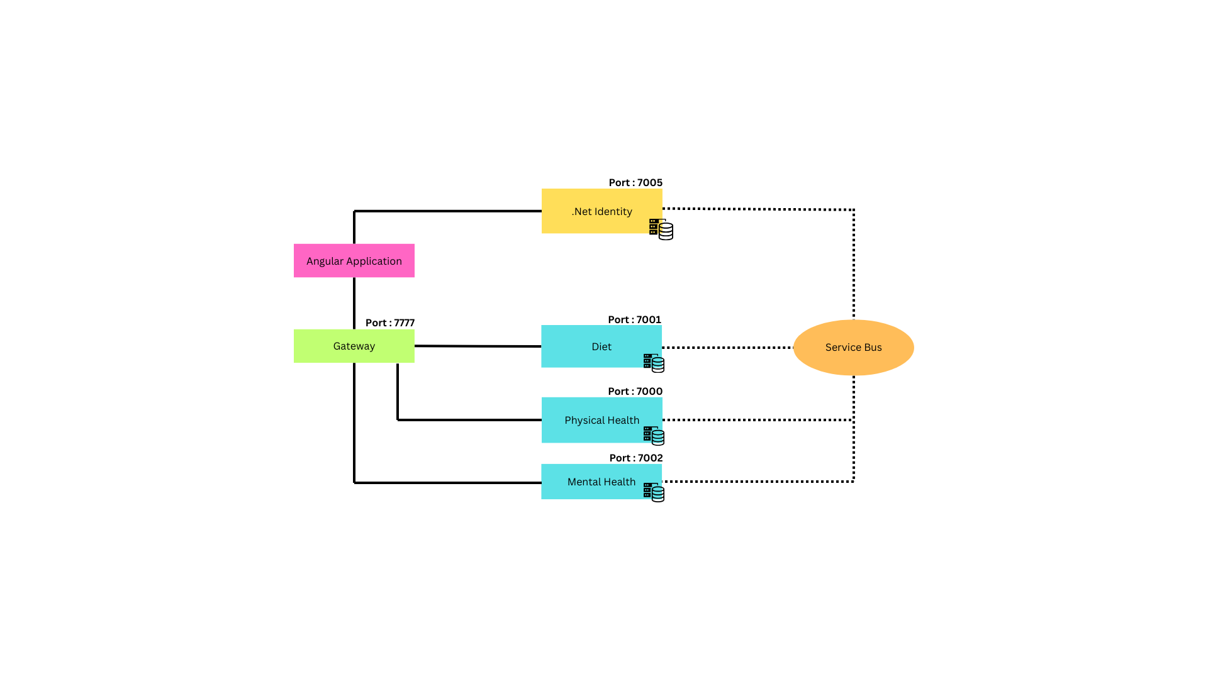

**Date: 05-11-2024**

Agenda:

1. Defining class diagrams

**Date: 06-11-2024**

Agenda:

1. Modifying the class diagrams according to microservices

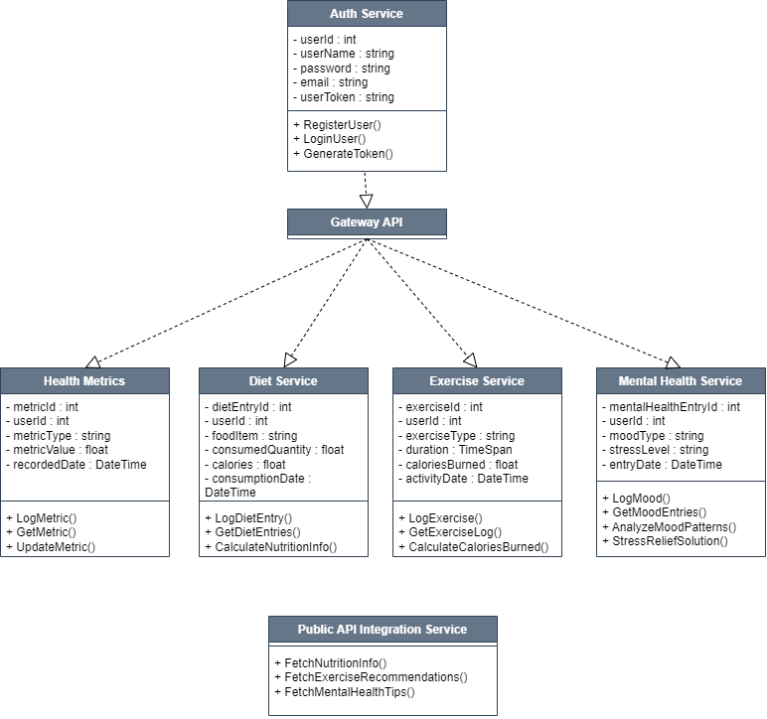

**Date: 07-11-2024**

Agenda:

1. Creating Flowchart

